Pickleball Site Plan

Taylor Asper

WDD 130

Overview

Purpose

The purpose of this pickleball website is to help people in Rexburg get connected with the sport. The site will share local places to play, events happening in the community, and recommendations for paddles. It is designed to help beginners, students, and regular players find information quickly and feel more included in the local pickleball scene.
The audience includes new players looking to learn the basics, BYU–Idaho students who want fun and social places to play, and local residents who want to stay updated on courts, events, and equipment.

Branding

Website Logo


Style Guide

Color Palette
Primary: #1E3A8A | Secondary: #FBBF24 | Accent 1: #10B981 | Accent 2: #F9FAFB
Deep blue | Gold | Green | Light grey

Typography

Heading Font: Montserrat

Paragraph Font: Open Sans

Navigation
Home Places to Play2 Paddles & Gear3

Content

[put all content for the pages here, including written text and images]

Home
Welcome to the Rexburg Pickleball Site!
Here you can discover the best places to play around town, check out upcoming events, and explore paddle and gear recommendations for all skill levels. Pickleball is one of the fastest-growing sports in the country, and this site makes it easy to get started or get better.

Img: Rexburg courts

Page 1
- Rexburg Nature Park Courts
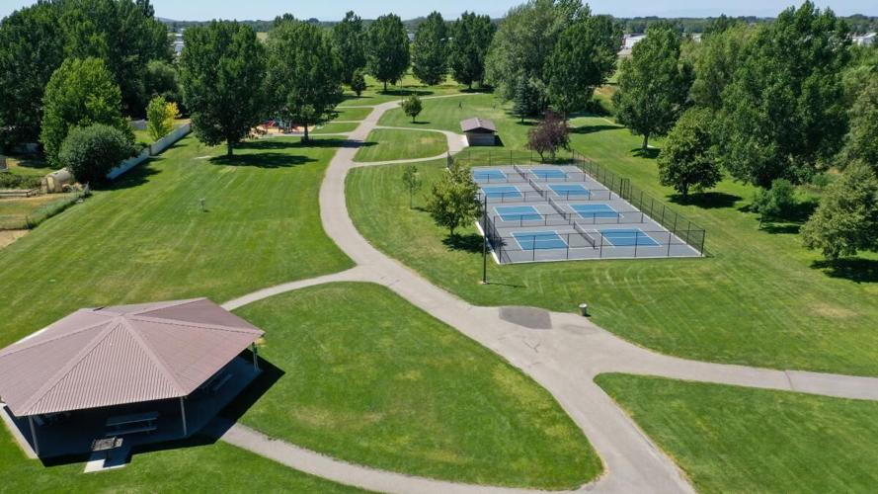
2. BYUI Courts
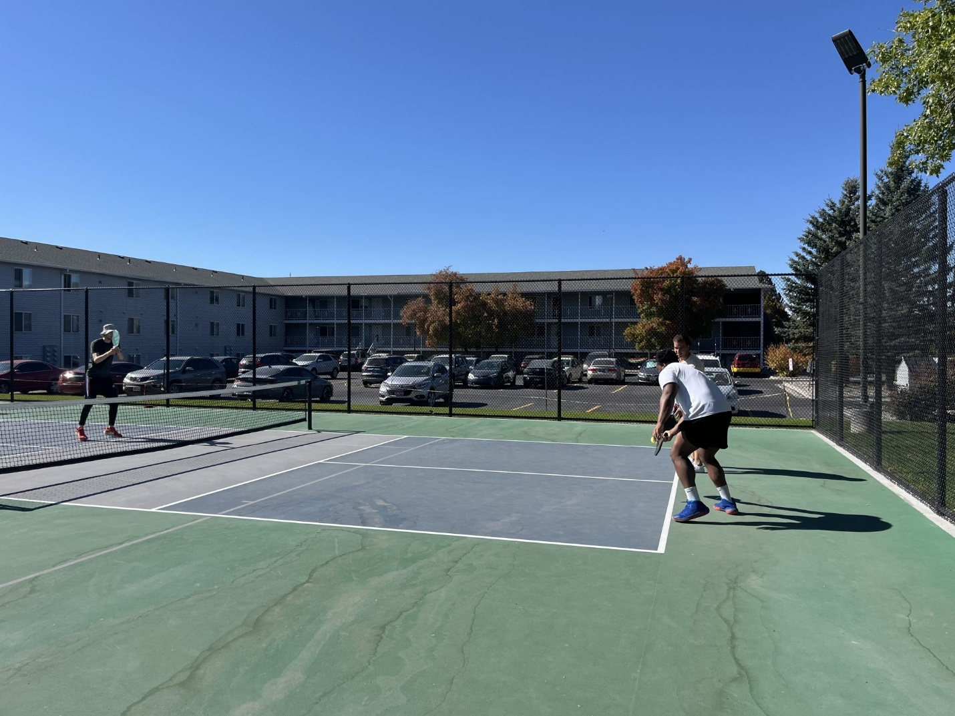
- Smith Park:
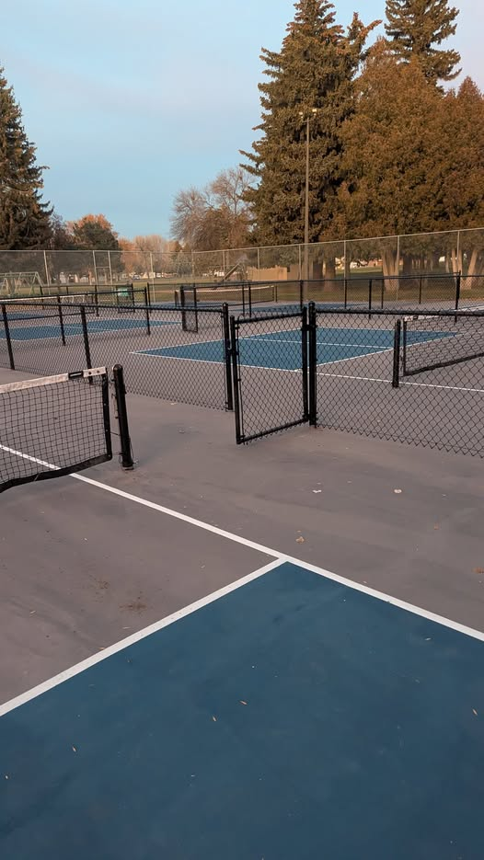
4. BYU-Idaho Hart building

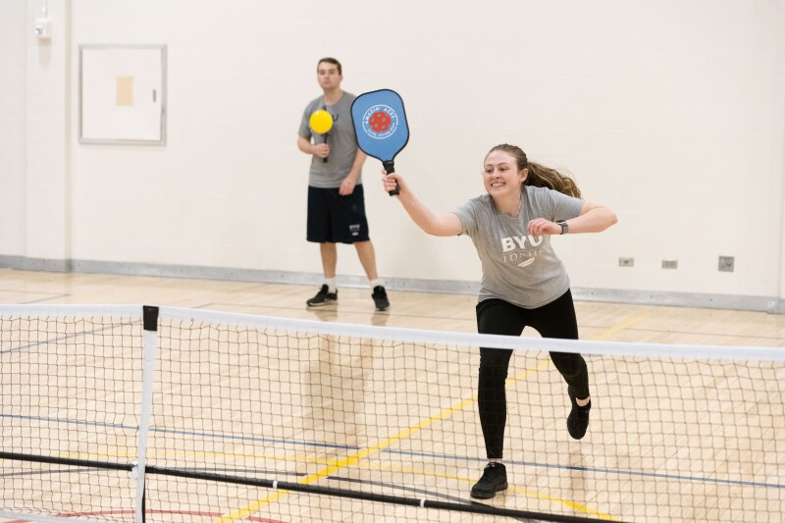

Page 2

This page highlights some of the top pickleball paddle brands so players can compare quality, style, and performance. Each brand is known for producing reliable, high-quality paddles used by players of all skill levels.

Selkirk is one of the most popular and trusted pickleball brands. They’re known for their premium materials, great control, and long-lasting construction. Many competitive players use their paddles.

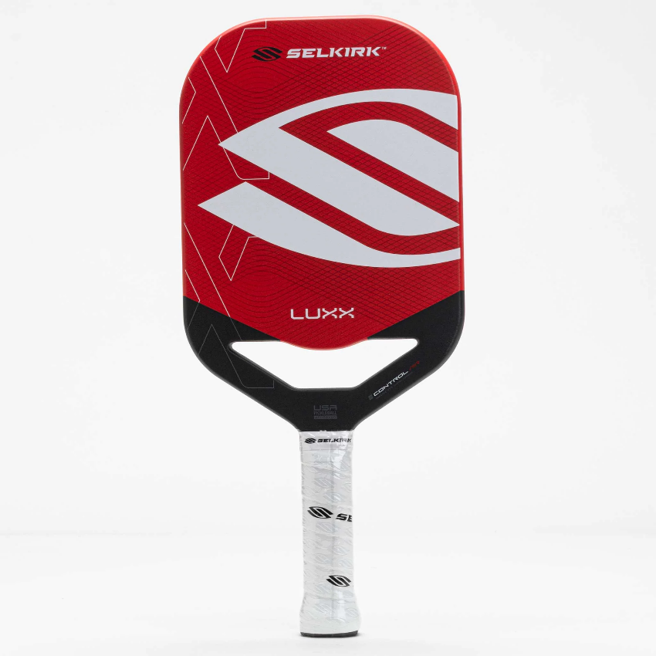

JOOLA makes powerful, spin-friendly paddles. They became extremely popular after partnering with pro player Ben Johns. Their paddles often use carbon fiber and advanced technology for better performance.

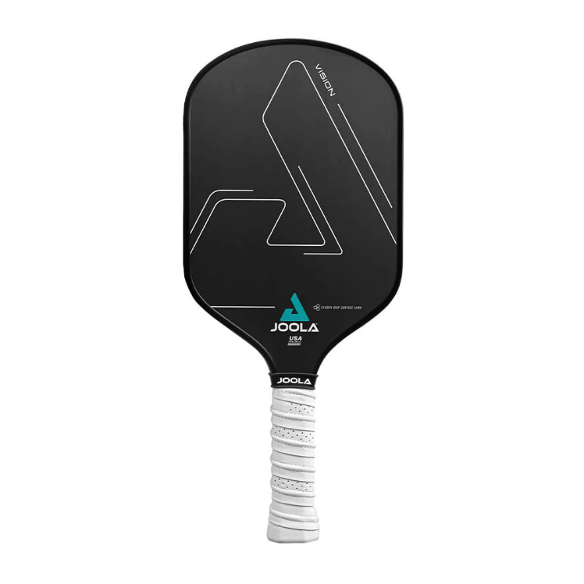

Onix is widely used among casual and competitive players. Their paddles tend to be powerful and durable, making them good for hard hitters and players who like aggressive shots. 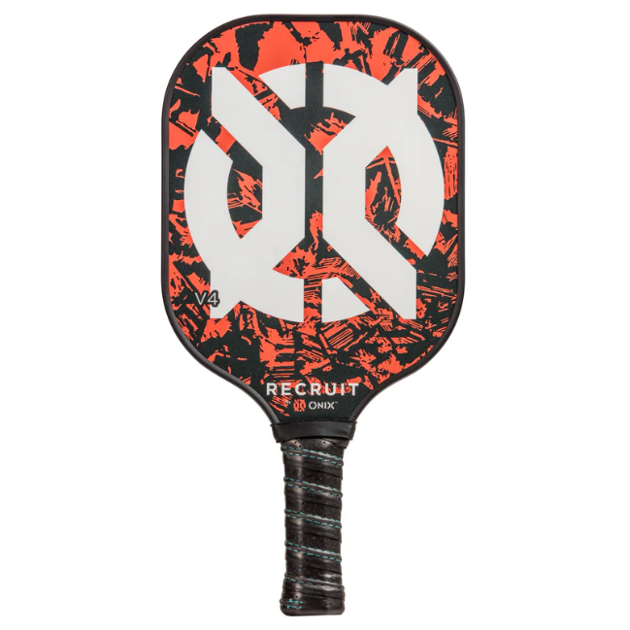

CRBN paddles are known for their carbon fiber surfaces that create excellent spin. Many advanced players love this brand for its blend of power and control.

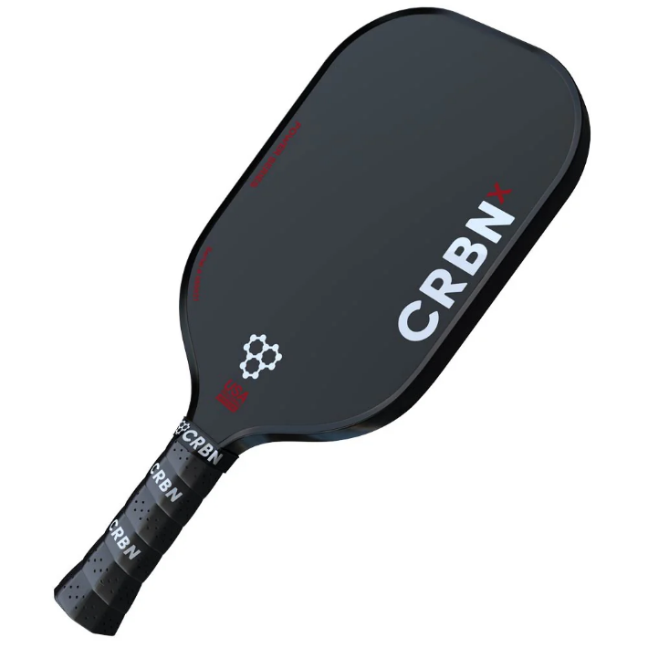

Friday is known for offering affordable, high-quality paddles with carbon fiber surfaces and good spin. Their paddles are USA Pickleball approved and come with a 99-day happiness guarantee. They’re popular for being lightweight, grippy, and budget-friendly.

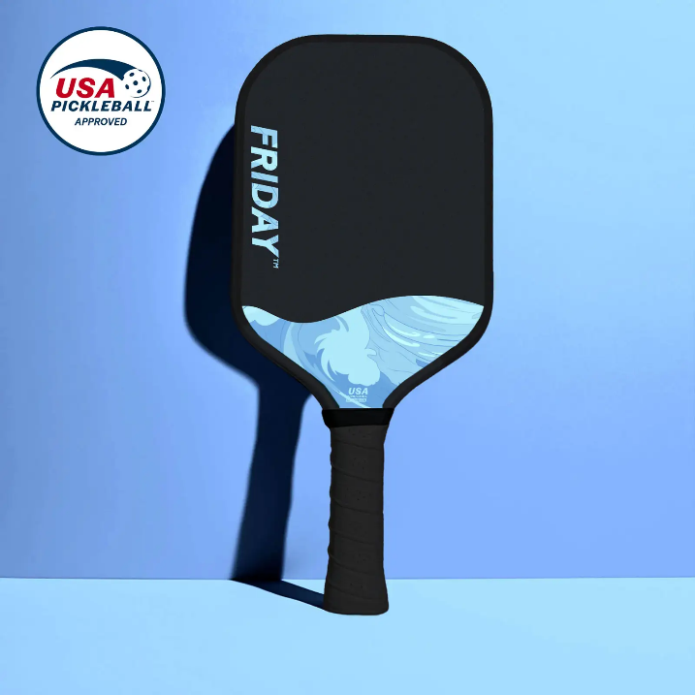

Ronbus is a growing pickleball brand known for its raw carbon surfaces and advanced engineering. Their paddles offer great spin, solid control, and a modern thermoformed design similar to high-end paddles — but usually at a more affordable price. Players like Ronbus for its quality, durability, and value.

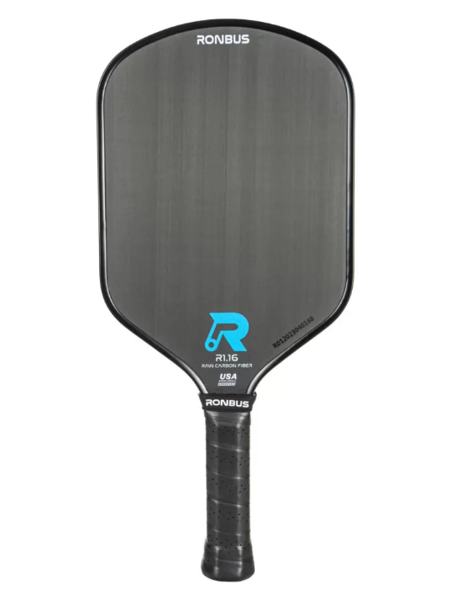

Wireframes

Home Page Wireframe

Example: 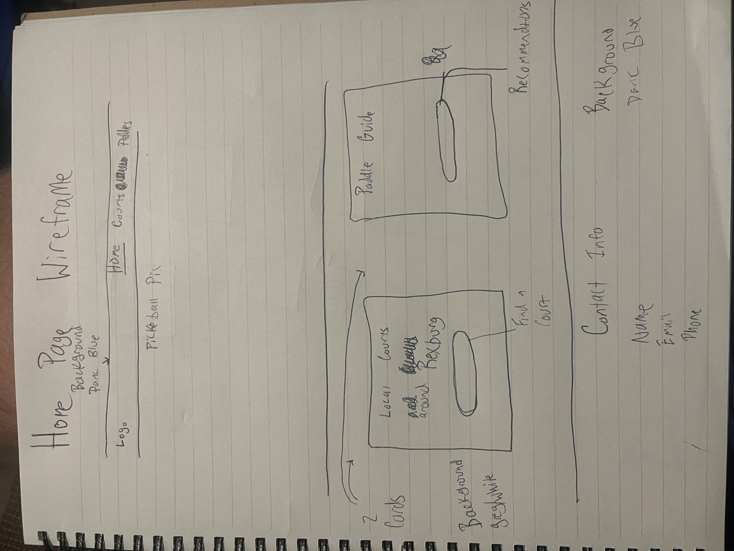

Page 1 Wireframe

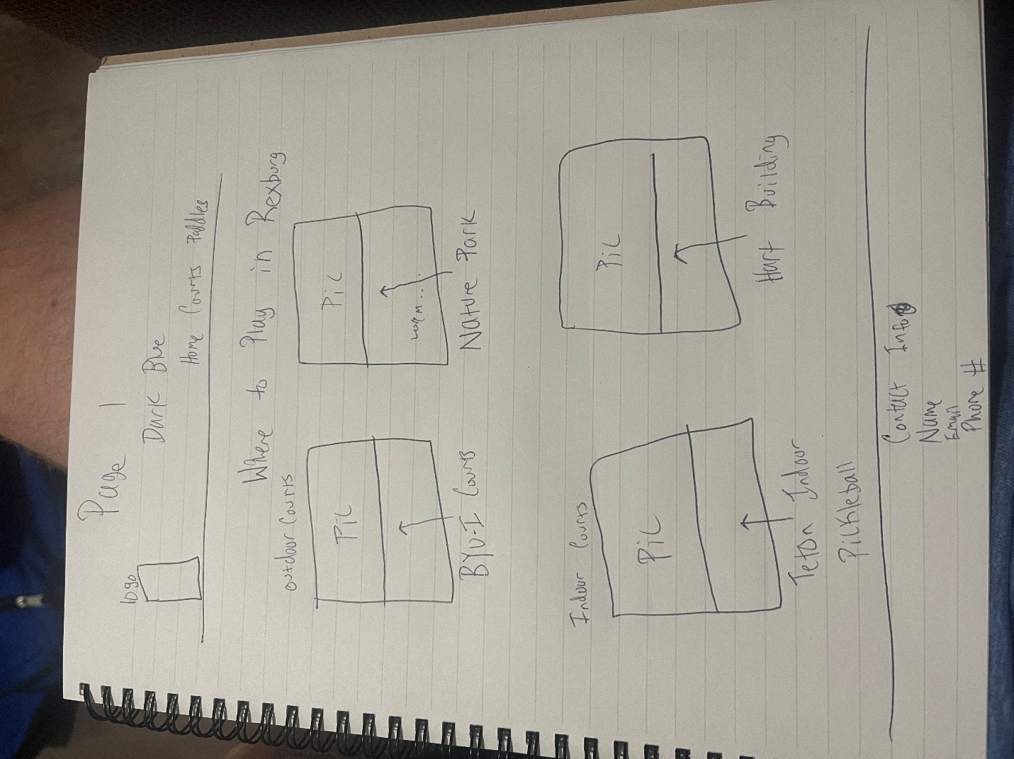

Page 2 Wireframe
